**Assignment One**

**Gram Filter Search Engine**

**Overview of Website Unique Functionality:** A Gram Filter Search Engine gives a gram-based framework by using category wise search and choose the high-quality grams as the prefix of query to achieve maximum filter performance. The main idea is to choose the high-quality grams as the prefix of query for their estimated ability to filter data. As this selection process is proved to be Natural Processing-hard problem, we give a cost model to measure the filter ability of grams and develop efficient heuristic algorithms to find high-quality grams for the user in the database.

This generalization provides a chance to select high quality combination of grams as a prefix of query from query-grams which is the input of user. A Gram Filter has a choose-and-extend framework to efficiently find the high-quality grams in the query process. It is a new measure of analyzing the overlap between the inverted lists. This is the key of synthetic criterion to generate better ordering of grams. With the help of synthetic criterion, grams can be selected efficiently and effectively.

**Overview of Website Layout:** My website has information regarding technologies. Where publisher will add the contents of data to the website and user will read the information also they can post questions to the website, one of the available publisher will answer the question. If it is a repeated question, then automatically the website will retrieve the data to the user. Admin is the head of this website he has control to authorize the publisher and user to use the website. I have prepared the website home page and registration form of user and publisher during registration also the login page of the website. I have used blue and light white colors to my website.

**Software Requirements**

**Operating System :** Windows XP or Later Updated Versions of windows

**Coding Language :** HTML, CSS, JAVASCRIPT, PHP

**Tool :** NET BEANS 8.2

**Database :** MYSQL 5.7.17

**Client Server Communication:** In this website, there are three types of users that is Admin, Publisher, User. I will be using JavaScript to communicate between client and server. If the user log in to the account, then the user related operations are retrieved from the server side like accessing information of Published notes and he can get list of queries from the database. Admin will get the list of number of publishers and users also the list of unapproved users and publisher. Admin can also retrieve the data and list of queries. Publisher will get the information regarding the information of published items and queries list that are to be answered.

**PHP/Server Side Code:** My website has two unique features one is category wise searching the data and retrieving it from MySQL database and another feature is if the user submits a query in the website and if the query is repeated then automatically the answer will be shown to the user. It’s a simple website so I will be using Hypertext Preprocessor Scripting language instead of JSP. Because php is easier than jsp.

**Advanced JavaScript:** I will be using HTML 5 for drag-and-drop files. When publisher wants to insert any file into website he can simple drag and drop the files.

**Importance of Web Standards:** Whenever we implement a website that must comply with web standards. Web standards are W3C that is world wide web consortium. This web standards are generally designed with forward and backward compatibility, so the data using older versions of the standards will continue to work in new browsers and data using new versions of the standards will gracefully degrade to produce an acceptable result in older browsers.

Complying with Web standards can give your Web pages greater visibility in Web searches. The structural information present in compliant pages makes it easy for search engines to access and evaluate the information in those pages, and they get indexed more accurately. Because use of Web standards makes it easier for server-side as well as client-side software to understand the structure of the document, adding a search engine to your own site becomes easier and gives best results.

**Modules**

**Admin Module:**

The Admin Module is responsible for maintaining the application like creating the useful Master Data for the Application, Granting necessary access permissions to the Application Users, and Generation of MIS (**M**anagement **I**nformation **S**ystem).

**Master Data Module:**

The master data module is accessed by Admin User Only. This module is responsible for creating necessary master data list for the Application.

**Members Registration Module:**

This module is accessible online for the general public on the Home Page itself. The public is categorized into two Member Groups. One Member Group is Publisher and other Group is users Group.

**Authorization Module:** This module facilitates the admin to grant the access permissions to the enrolled members of the application.

**Publisher Module:**

A Publisher can Publish their content under any available Categories by Upload the flat files also they can do the below operations.

* List of Contents Already Published by them earlier
* List of New Queries Raises by the Users
* Send Replies to the User Queries
* And, two more facilities provided to the publishers are

Changing their Current Password and User Profile

**Users Module:**

User can get the list of submitted queries by him. A facility of composing their queries in any available category and submit them to the publisher.

**Management Information System Report:**

The MIS Module provides various Managerial Reports to the High-Level Management for their analysis purpose.

* List of Available Categories
* List of Publishers
* List of Users
* List of Queries not yet replied
* List of Category Wise Queries
* List of Uploaded Contents

**Diagrams**

**Website Overview Representation in Use Case Diagram**



**Entity-Relationship Diagram of Database**



**Website Design**

**Home Page**

Home page contains member login and registration form buttons



**Registration Page**

Registration form of the website. In order to register as publisher or user you must select on member type and register

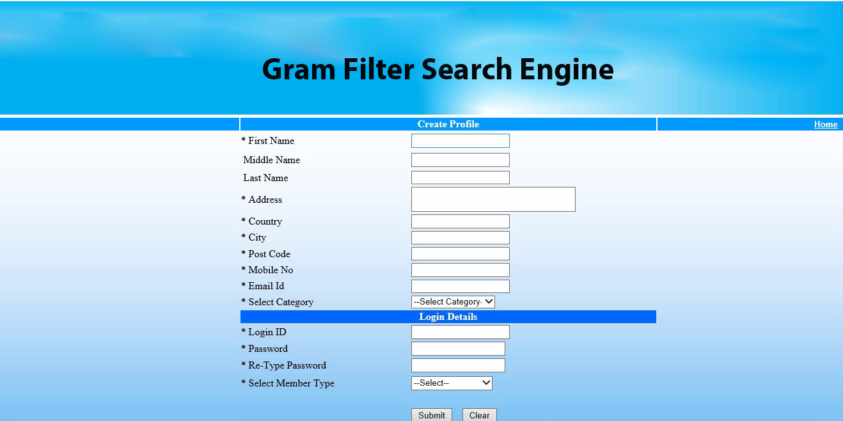

**Login Page**

Login page for admin, publisher and user

